Lab 02

Rectification
Name: Syed M. Asad Ali, Laiba Munib | Student ID: sa09475, lm09327

Objective
To investigate the performance of half-wave and full-wave rectification circuits implemented using diode.

Introduction
Rectifiers are the circuits which convert Alternating Current (AC) to Direct Current (DC). Diode, a unidirectional two-terminal non-linear electronic component, is a fundamental element of rectifiers because of its ability to conduct current in one direction and block in the other direction. Rectifiers can be classified into two classes; half-wave rectifiers and full-wave rectifiers. Full-wave rectifiers are further characterized into two types that are center-tapped rectifier and bridge rectifier. Rectifiers are found in all DC power supplies that operate from an Alternating Current (AC) voltage source.
Performance of a rectifier can be measured using a parameter called ripple factor. The smoother the output waveform, the smaller the ripple factor is. A perfect DC output does not have any ripples or in other words any AC component. Consequently, the RMS component is equal to the DC component which results in 0 ripple factor. Ripple factor can be expressed as:
Where, V_{rms} is the root mean square value of output voltage and V_{dc} is the average or mean value of output voltage which is equal to the DC component.

Half-wave Rectifier
Half-wave rectifier is shown in Figure 2.1. Its working principle is based on the bias condition of diode. Since diode allows current to pass through it only when it is forward biased and behaves as an open-circuit when it is reverse biased, therefore, when AC sinusoidal signal is applied to a load through diode, the current flows through the load only in half cycle of the input sinusoid where the diode is forward biased. Thus, the AC sinusoidal input voltage is converted into pulsating DC through half-wave rectifier.
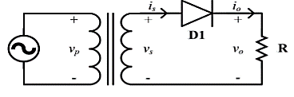
Figure 2.1: Half-wave rectifier circuit

Task 1: To simulate half-wave rectifier circuit using PSpice
Figure 2.1 shown implementation of half-wave rectifier circuit in OrCAD PSpice. Here, an AC voltage source is connected to a step-down transformer (240V/24V). The AC voltage source of 240V with 50 Hz frequency simulates supply from outlet at your home. The amplitude is reduced down using a step-down transformer. Usually, the required output of DC power supply is not as high as 240V therefore, before rectification, the amplitude of AC signal is stepped down.
Figure 2.1: Schematic for simulation of half-wave rectifier circuit
- Implement the circuit using OrCAD Capture. PSpice model name of the AC voltage source is VSIN. To add a transformer, go to Place> PSpice Component > Modelling Application > System Modules > Transformer. Make sure Two Winding is selected. In listed properties, change turns ration to 0.1 i.e., the secondary voltage is 10 times lesser than the primary voltage. At the output terminals, connect a load resistor of 1kΩ through a half-wave rectifier (diode model 1N4007).
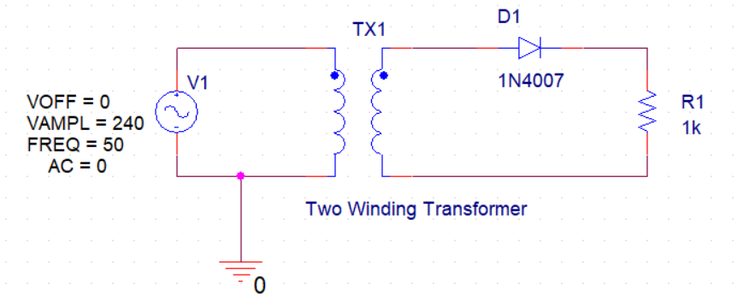
- Run Transient Analysis and set run time to 0.2sec to at least view 10 cycles of AC supply. Set the value of maximum step size to 0.001sec, in order to get a smoother waveform.
- Obtain waveforms of voltage across load, voltage across diode (using differential voltage markers) and secondary voltage of transformer. Obtain current waveform in a separate window. Add captures of the obtained plots.
- In which half cycle of the supply, the diode conducts? Explain how you can identify the conduction of diode from the obtained waveforms.
The diode conducts in the positive half of the supply, as we can see waveforms that the load has a voltage going through it in the positive half of the supply since its graph does not go in the negative axis. From this, we can conclude that the diode allows conduction in the positive half only otherwise the load would not be on at that time.

- Can we say that the circuit works as a rectifier? Justify your answer. Why this rectifier is called half-wave rectifier?
The above circuit can work as a rectifier since it converts AC output to DC. It’s known as a half-wave rectifier because the output is produced only in one half of the supply and not the other half of the diode.

- For the obtained output voltage, measure the parameters listed in Table 2.1.
PSpice Measurement Help:
- To add plots for RMS (Root Mean Square) and average values of the output voltage, go to Trace > Add Trace. In Add Traces Window, you will see Functions listed at right hand side. Select RMS ( ). In parenthesis, write the expression of output voltage V (R1:2 - R1:1) where, terminal 2 of R is connected to ground. Discard starting few cycles, consider the waveform when voltage becomes stable.
- Similarly, add trace for average value by selecting AVG ( ) from functions. In parenthesis, write the expression of output voltage V (R1:2 - R1:1) where, terminal 1 of R is connected to ground.
- Exact value can be read using cursors for the added traces. When measuring the values, ignore the first few cycles.
- Frequency can be calculated by measuring the time period of waveforms.

Full-wave Center-Tapped Rectifier
A full-wave center-tapped rectifier uses two diodes as shown in Figure 2.2 to allow both; the negative and the positive, half cycles of the input AC voltage to appear across the load such that the current through the load does not change its direction. Thus, full-wave of the applied AC input is rectified. The two diodes are connected to the opposite ends of a center-tapped transformer where the center-tap is usually considered as the reference ground. The voltage that appears at the 2 secondary terminals of transformer with respect to center tap is always equal in magnitude but opposite in polarity.
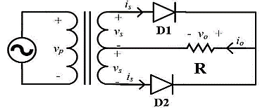
Figure 2.2: Full-wave center-tapped rectifier circuit

Task 2: To implement full-wave center tapped rectifier circuit on hardware
- Figure 2.3 shows the circuit implementation of a full-wave center tapped rectifier circuit. Construct this circuit and use RL=1K ohm of 0.5W rating.
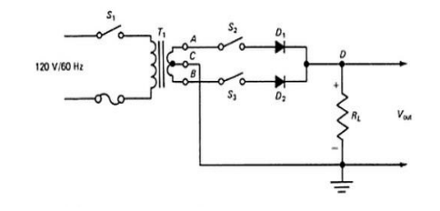

Figure 2.3: Schematic of full-wave center tapped rectifier
- To understand the secondary voltages of center, tap transformer, obtain waveforms of voltage across the 2 secondary terminals with respect to the center tap using the digital Oscilloscope. Make sure your oscilloscope probe is set to 1x. Sketch and label the waveforms.
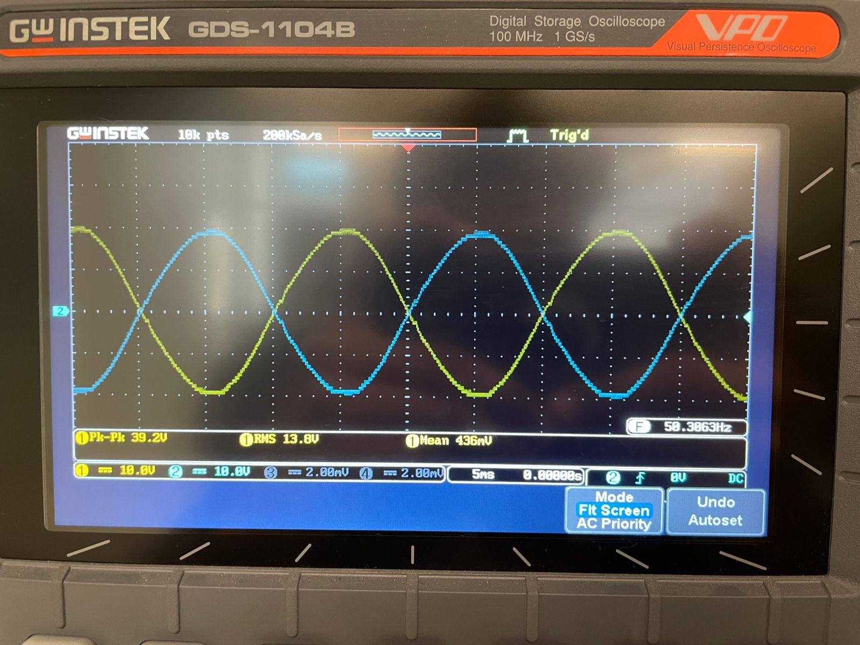
- Observe the waveforms of voltages, first open circuit the Diode 2 using switch and measure voltage across Diode 1, then open circuit Diode 1 and close circuit Diode 2 to measure the voltage across diode 2. Sketch and label both the waveforms in graph 1.
- Now, close both the switches and measure voltage across the Load resistor. Sketch and label the waveform in graph 2.
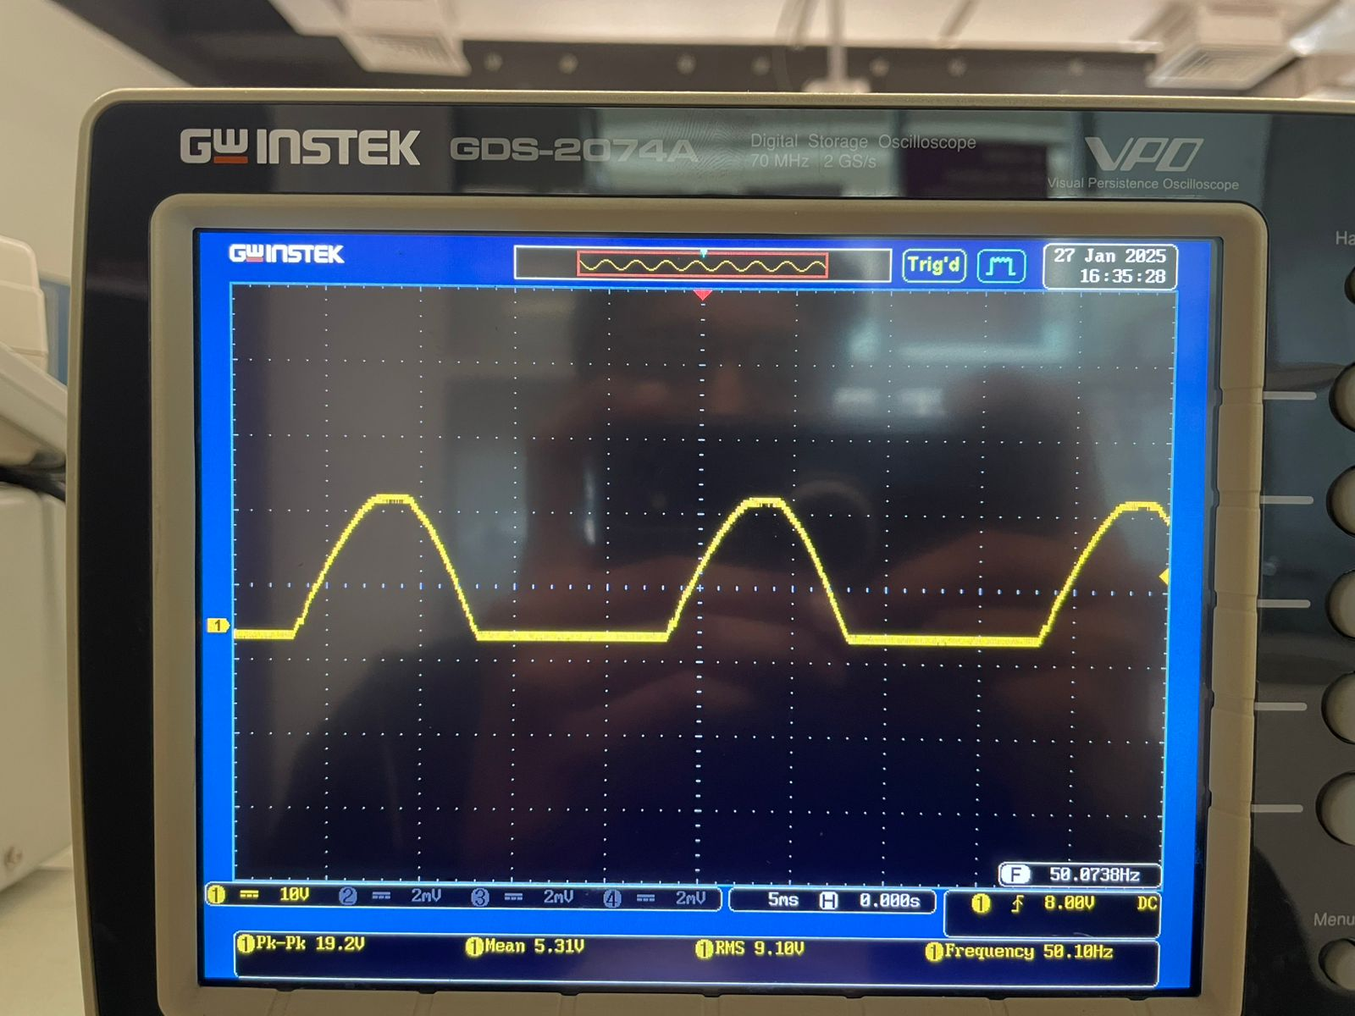
Voltage across when Diode 1 on or when Diode 2 on
(V_D1= 3.96 V)(V_D2= 4V)
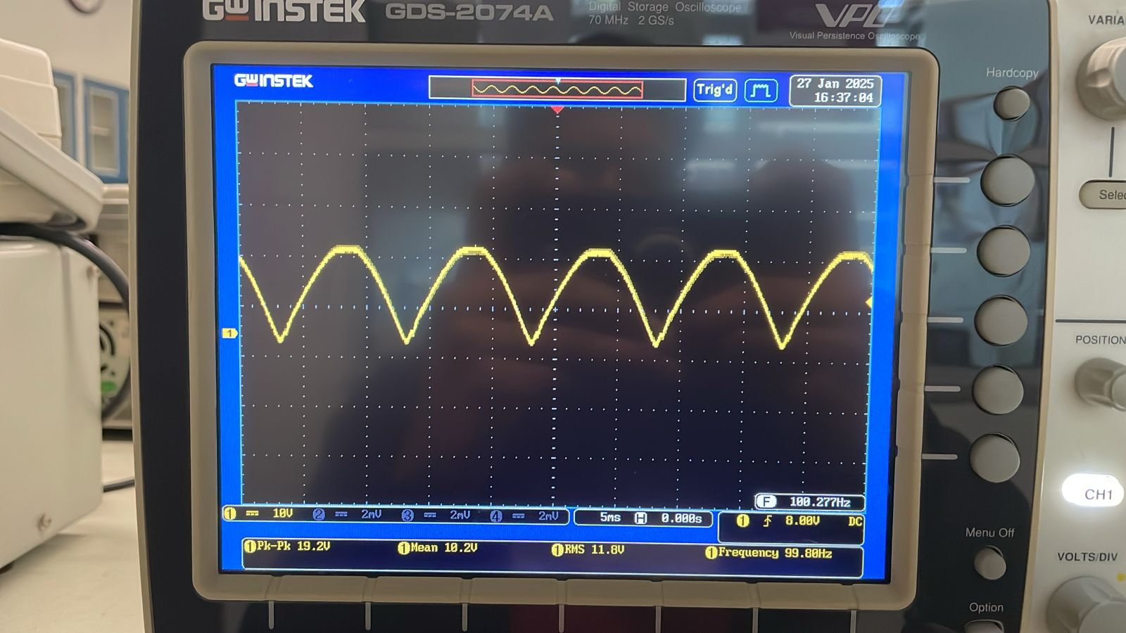
Voltage when both diodes on
(V_R= 12.3V)

- Take measurements for the parameters listed in Table 2.1 and fill in the column for center-tap rectifier.

How to set AC or DC coupling in Oscilloscope?
If the probe is connected to Channel 1 of the scope, then, in order to set coupling, press the CH1 button and you will see that it lights up just like Figure below and on the bottom of the screen 3 options under coupling will appear DC AC GND.

- DC- represents the scope will show both AC and DC components of the waveform/signal.
- AC-represents the scope will show only the AC component of the waveform/signal.
- GND- suppresses both the AC and DC components of the waveform/signal, it is generally used to set the wave/signal to a specific reference position on the screen.
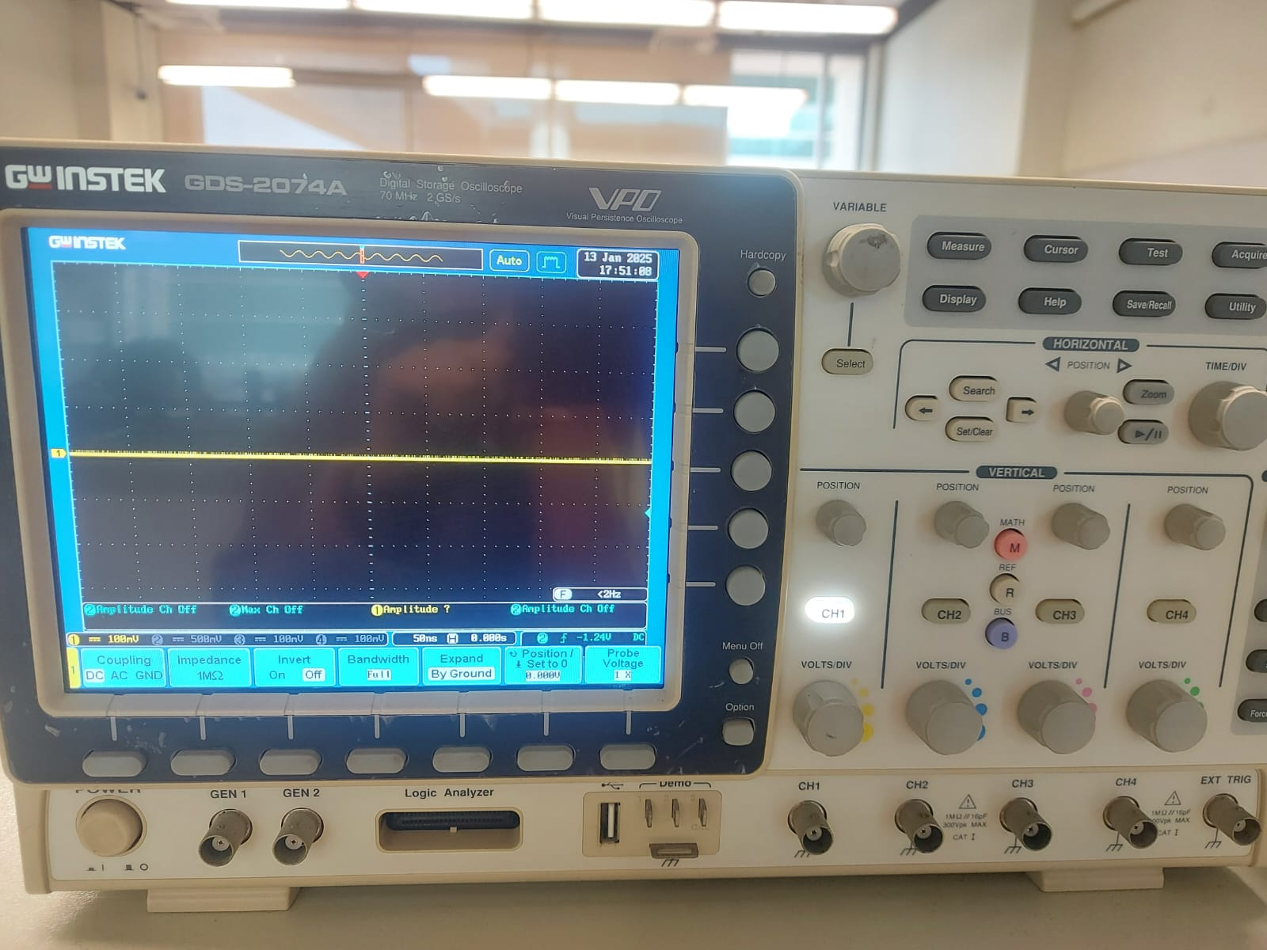

In order to select any of the above stated options press the button highlighted in the Figure below:

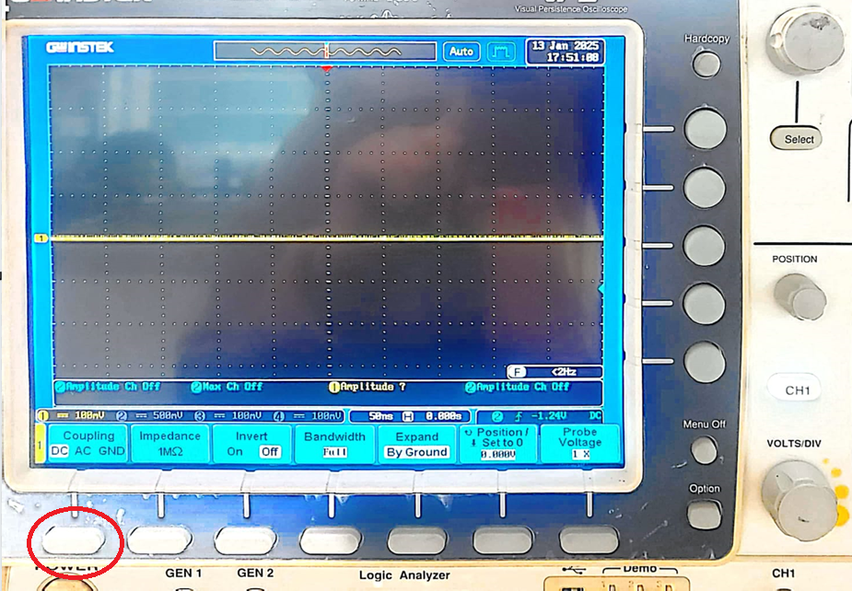

- How is the output of this rectifier different from the half-wave rectifier?
Unlike a half-wave rectifier, this rectifier rectifies the negative component of voltage to positive to give a pulsating DC wave.

- Explain why only one diode conducts at a time.
One diode is reverse biased at each instance and conducts when voltage is negative, whereas the other one is forward biased and conducts when the voltage is positive.

Full-wave Bridge Rectifier
A full-wave bridge rectifier is shown in Figure 2.4. There are four diodes connected in a configuration like that of a Wheatstone bridge. In positive half- cycle, the diodes D1 and D4 will conduct and in negative half-cycle the diodes D2 and D3 will conduct. Thus, the current through the load flows in one direction and full-wave of the input is rectified. This configuration of full-wave rectifier doesn’t require center-tap of transformer.
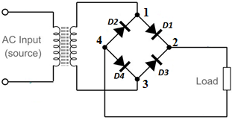
Figure 2.4: Full-wave bridge rectifier circuit

Task 3: To implement full-wave bridge-rectifier circuit on hardware
- Implement the circuit shown in Figure 2.5.
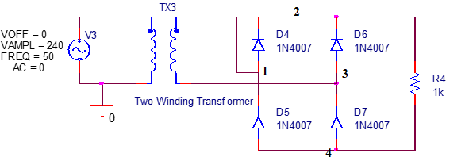
Figure 2.5: Schematic for simulation of full-wave bridge rectifier
- Obtain waveforms of voltage at Nodes 1 and 3 with reference to Node 4 and the output voltage which is at point 2 in with reference to Node 4 in Figure 2.5. Note that, Node 4 is the Reference Node.
- Sketch and label the waveforms in the box below.
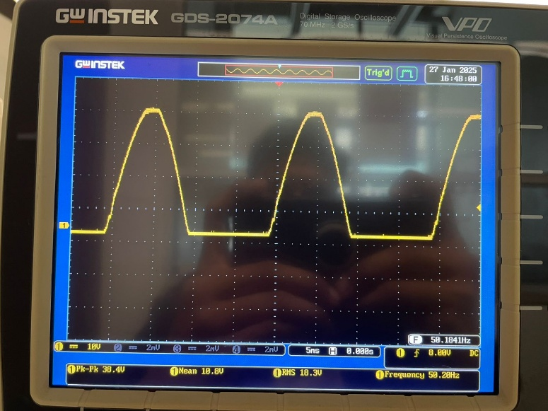
Across Node 1
(Vrms = 20.9 V)
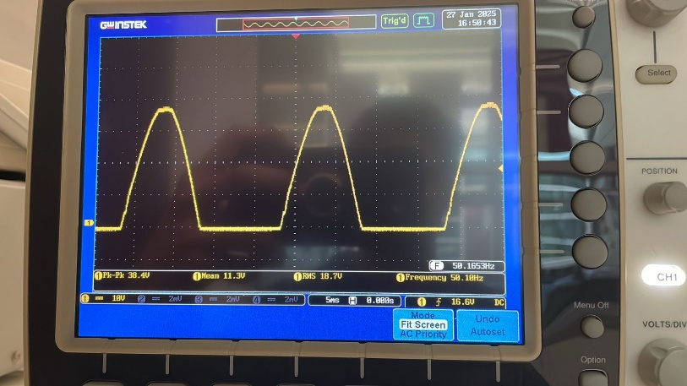
Across Node 3
(Vrms = 21.0 V)
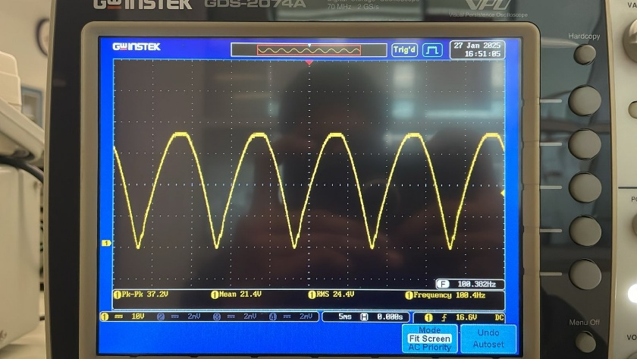
Across Node 2
(Vrms = 27.2 V)
- Identify the diodes that conduct in positive half-cycle of the supply waveform and the diodes that conduct in negative half. Explain why only 2 diodes conduct at a time.
From Figure 2.4, the two diodes that conduct in forward bias are D1 and D3 and in reverse bias D2 and D4 conducts.
- Take measurements for the parameters listed in Table 2.1 and fill in column for bridge rectifier.
- How is the bridge rectifier circuit different from the center-tap rectifier circuit?
A bridge rectifier uses four diodes in a bridge configuration. It provides a higher output voltage and better efficiency by utilizing both halves of the AC cycle. A center tap uses two diodes, one for each cycle, and only one diode conducts during each half cycle due to which voltage drops across only one diode during conduction resulting in lower losses.

Table 2.1: Performance parameters of half-wave and full-wave rectifiers
Parameters | Half-wave Rectifier | Full-wave Center Tapped Rectifier | Full-wave Bridge Rectifier | Full-wave Bridge Rectifier with Filter
Input Frequency: f_{in} | 50 Hz | 50.23 Hz | 50.16 Hz | 50.14 Hz
Output Frequency: f_{o} | 50 Hz | 100.1 Hz | 99.80 Hz | 99.76 Hz
Output DC Voltage: V_{dc}  (Mean value in DC coupling mode) | 7.7848 V | 10.9 V | 23.9 V | 21.9 V
Output RMS Voltage (AC): V_{RMS (AC coupling only)} | -
Output RMS Voltage (Total i.e., AC+DC): V_{RMS (DC coupling)} | 11.850 V | 12.3 V | 27.2 V | 23.4 V
Ripple Factor: γ | 1.148 | 0.523 | 0.54 | 0.376

Task 4: Effect of Filters to Reduce Ripples
The instantaneous output voltage of full-wave rectifiers still has ripples as represented through plots and ripple factor. Note that the added Traces for average and RMS values (straight lines) do not represent the instantaneous voltage. These measurements are just a number to measure the average and RMS values of instantaneous voltage that appears across the load.
Filter circuits are used to smoothen the output. Passive filters are made of inductors and capacitors in series or parallel combinations. In this lab, the effect of shunt capacitor-based filter will be investigated. Since a capacitor is open to DC and offers low impedance path to AC current, putting a capacitor across the output will make the DC component to pass through the load resulting in small ripple voltage. The working of the capacitor can be understood in the following manner. When the rectifier output voltage increases, the capacitor charges to the peak voltage V_{m}. After the positive peak the rectifier output voltage tries to fall. As the source voltage decreases below V_{m}, the capacitor will try to send the current back to diode making it reverse biased. Thus, the diode disconnects the source from the load and hence the capacitor will discharge through the load until the source voltage becomes more than the capacitor voltage. The extent to which the capacitor voltage drops depends on the capacitance and the amount of current drawn by the load; these two factors effectively form the RC time constant for voltage decay. A proper combination of large capacitance and small load resistance can give out a steady output.

Task 4: To add filter for reduction in ripple component of rectifier output
- Implement the following circuit change the supply magnitude to 24V. Connect a capacitor in parallel to the load as shown in Figure 2.6.
Figure 2.6: Schematic of bridge rectifier with filter capacitor in parallel
- Obtain waveform of instantaneous voltage across load with and without capacitor. Sketch the waveforms in the graph below.
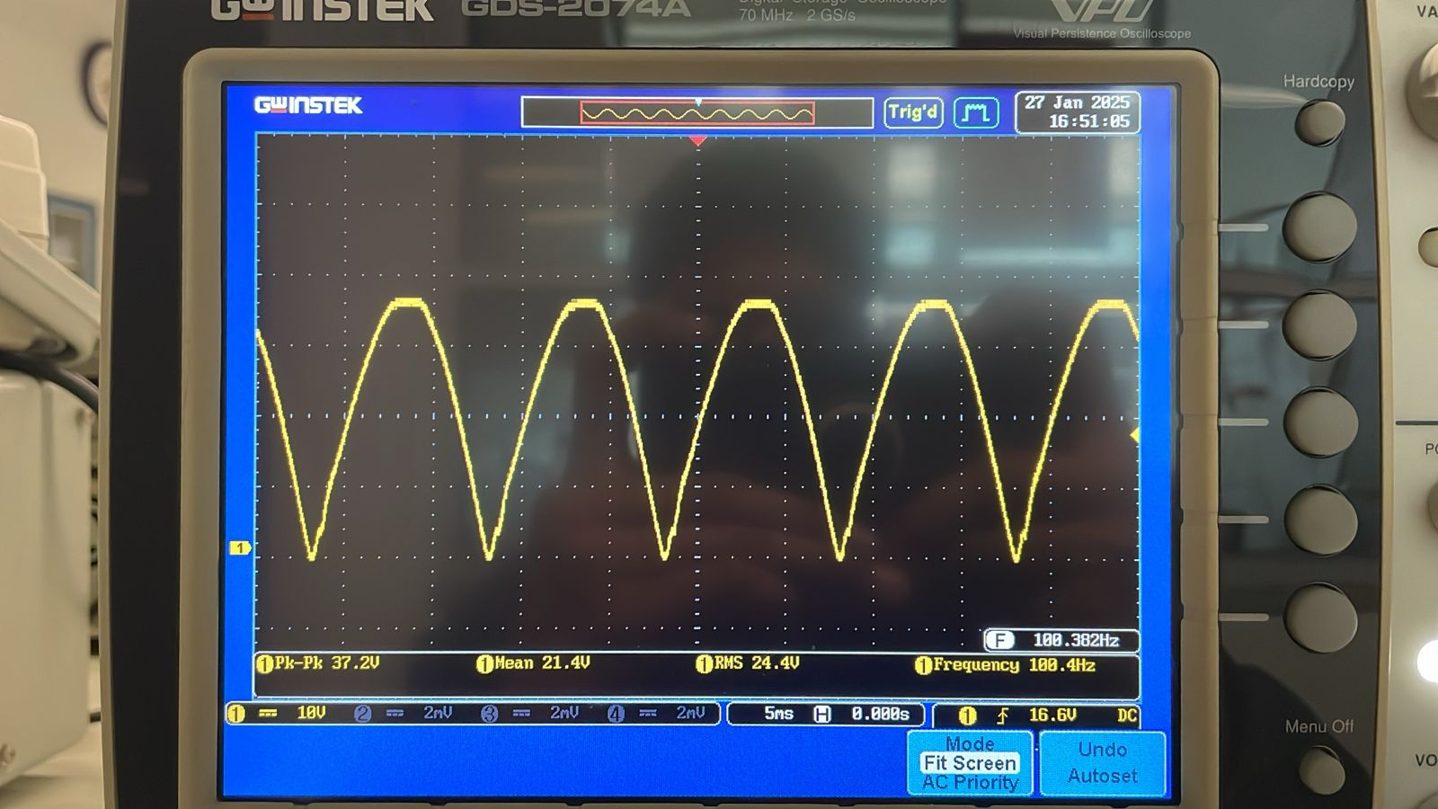
Without capacitor
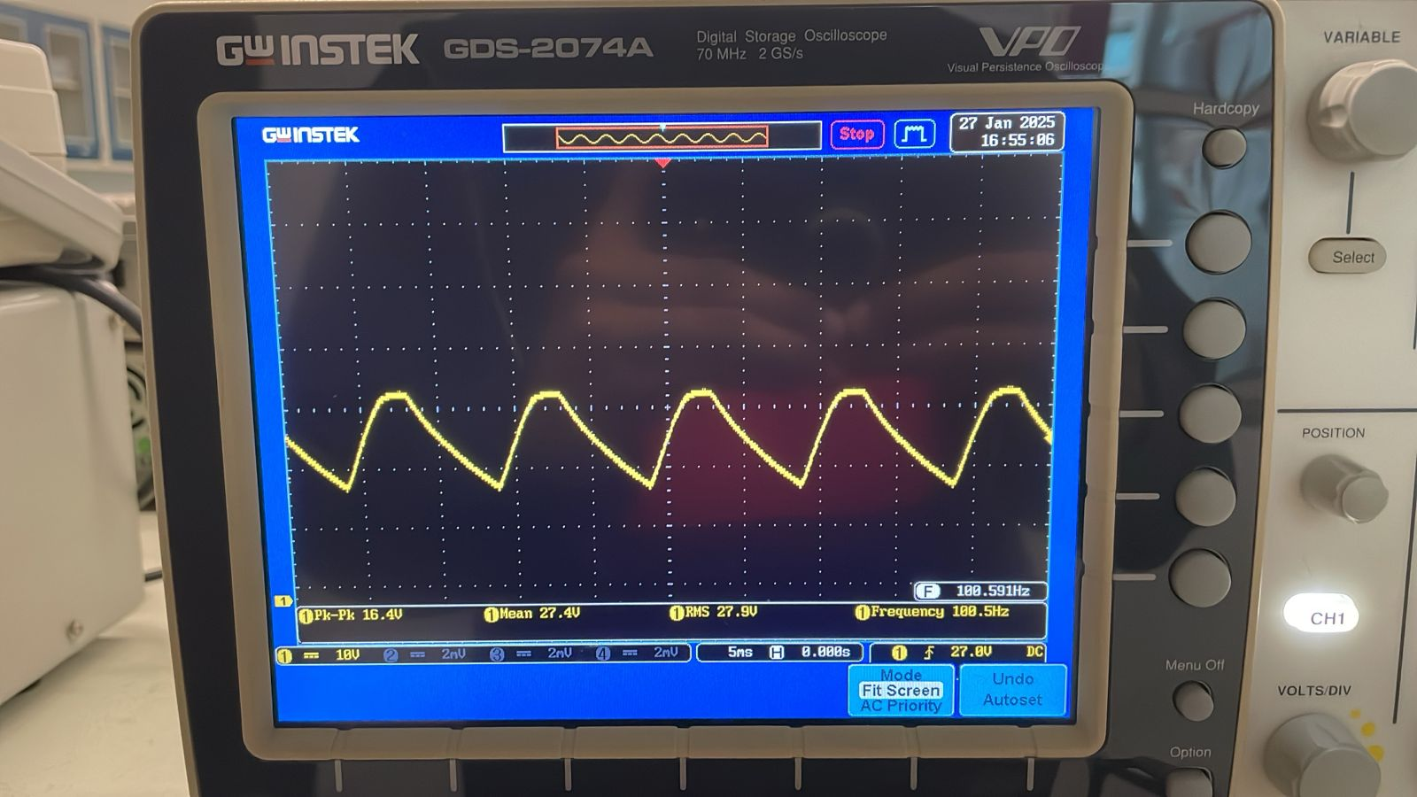
With capacitor
- How is it different from the output voltage without filter? Is there any effect of increasing or decreasing capacitance?
Instead of pulsating DC, the wave takes time to charge because of the capacitor, if we increase capacitor so it will take more time to charge so more faltter wave.
- Take measurements and fill in the last column of Table 2.1.

Post Lab

Task 5: To compare the performance of rectifiers
- Compare the performance of half-wave, full-wave center tap and bridge rectifier with and without filter in terms of the listed parameters one by one using the data collected in Table 2.1.
The input and output frequencies seem to be the same for the four rectifiers. As for half waves rectifier, it has the lowest DC voltage output and RMS voltage while the full-wave rectifier has a significantly higher DC Voltage and a higher RMS voltage. After filtering, the DC voltage has been reduced and RMS voltage also reduces due to smooth DC output. If we talk about the ripple factor, in general higher ripple factor means a lot of AC fluctuations and filter significantly reduces the ripple.
In conclusion, half-wave has the worst performance while full bridge rectifier with filter gives the smoothest output.
- One of the purposes of the transformer is to provide isolation between the digital Oscilloscope and the supply. Explain what is isolation and how does a transformer achieve that.
Isolation means there is no direct connection between two circuits to prevent unwanted current flow between circuits which provides safety for electrical components. Since, transformers are elements with high voltages it provides isolation so the oscilloscope is protected from direct contact with high voltage.
A Transformer provides isolation by the coils in it and the magnetic induction that transfers energy without any contact.
- Explain how you can fix the output voltage amplitude to 10 volts only. Draw a schematic for that.
We can use a voltage regulator to fix the voltage and from previous lab we can use a Zener diode as the voltage regulator and set it to 10V. It will allow current to flow if it exceeds the breakdown voltage.

Assessment Rubric
Lab 02
Rectification
Name: | Student ID:

Points Distribution

Task No. | LR2  Simulation  5 | LR 4  Data Collection  20 | LR5  Plots  20 | LR 6  Calculation  12 | LR 10  Analysis  35
Task 1 | /5 | /5 | /5 | /3 | /8
Task 2 | - | /5 | /5 | /3 | /5
Task 3 | - | /5 | /5 | /3 | /5
Task 4 | - | /5 | /5 | /3 | /5
Task 5 | - | - | - | - | /12
Total | /5 | /20 | /20 | /12 | /35
CLO Mapped | CLO 3 | CLO 2 | CLO 1 | CLO 1 | CLO 1

Affective Domain Rubric |  | Points | CLO Mapped
AR 3 | Pre-Lab Submission | /4 | CLO 4
AR 4 | Report Submission | /4

CLO | Total Points | Points Obtained
1 | 67
2 | 20
3 | 05
4 | 8
Total | 100

For description of different levels of the mapped rubrics, please refer the provided Lab Evaluation Assessment Rubrics and Affective Domain Assessment Rubrics.

Mean Value can be selected by adding measurements using Measure button in Oscilloscope.

